Description： | ELITE BULL BAR To Suit FORD RANGER 2012-2016
Model： | Ford Ranger/2012-2015
Item NO： | BBRA-RANGER

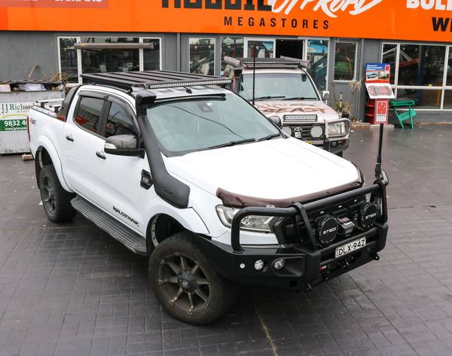

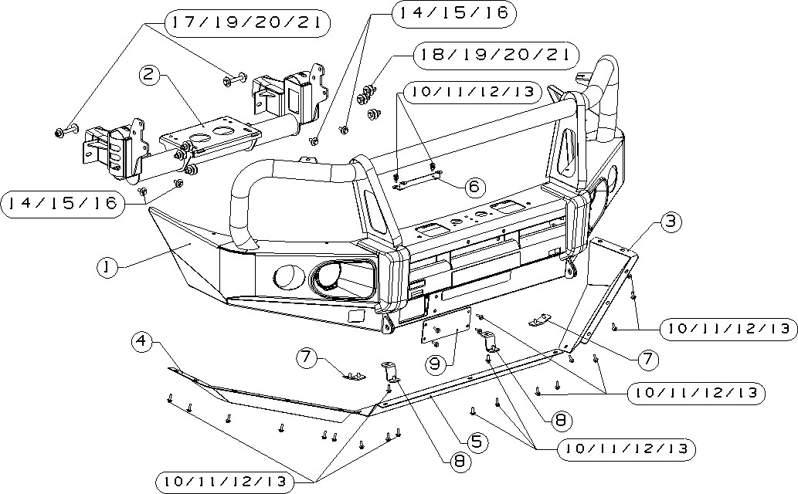

Note: PLEASE READ BEFORE ATTEMPTING INSTALLATION.
- All Rockarmor products are manufactured to highest of standards and latest finishes including sand blasting all raw material and e coating to clear the product of any impurities and finished with a tiger coat to keep the longevity if at any stage while off road or on road use this product is damaged or scratched have the damaged surface repaired.
- This product and its fixings must not be modified in any way unless stated in this fitting instruction.
- Do not remove labels from this product.
- Do not use this product for any vehicle other than specified in these instructions.
- It is the installer’s responsibility to assure this product is installed correctly allowing enough tolerance for movement between the chassis and body and clearance of all components.
- Use Loctite on all nuts and bolts.
- The installation of this product may require the use of specialized tools and or trained fitter.

For more information regarding this product please visit www.Rockarmor.com.au

The following tools will be required to install the product.

Metric Socket Set 10-18MM.
Socket Extension Bar
Metric Spanner Set 10-18MM.
Torx Drivers T25-T30
Trim Removal Tool
Screwdriver Set (Flat and Phillips head)
Utility Knife
Side Cutters
Pliers
Impact Drill
Loctite
Cable Ties
Masking Tape
Satin Black Automotive Paint
Grease and wax Remover
Scotch Brite or Fine sandpaper

Standard locking torque
M6 - 11Nm | M8 - 18Nm | M10 - 80 Nm | M12 - 90 Nm | M16 - 90 Nm

Material list

Item | item NO. | Description | Qt y |  | Item | item NO. | Description |  | Qt y
○1 | R28000561901 | 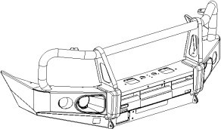  Bull bar assemble | 1 |  | ○2 | 20006993701 | 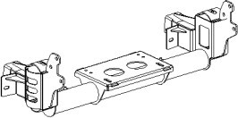  Winch Frame |  | 1
○3 | R28000564401 | 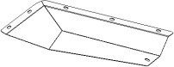  Skid Plate（LH） | 1 |  | ○4 | R28000564501 | 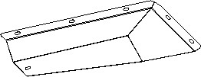  Skid Plate（RH） |  | 1
○5 | R28000564601 | 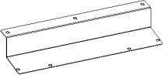  Middle Skid Plate | 1 |  | ○6 | 20008945001 | 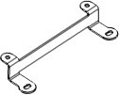  Bracket |  | 1
○7 | 20012640501 | 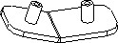  Skid Plate junction plate 1 | 2 |  | ○8 | 20006998201 | 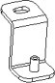  Skid Plate junction plate  2 |  | 2
○9 | R28000370901 | 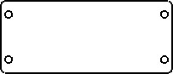  Plastic blanking plate | 1
 |  | Hardware kit
Item | Item NO. | Description |  |  |  |  |  | Qty
10 | 3002529 | Hexagonal head bolt M6_25 |  |  |  |  |  | 30
11 | 3000222 | Washer D6 |  |  |  |  |  | 32
12 | 3000136 | Spring washer D6 |  |  |  |  |  | 30
13 | 3001471 | Hexagon nut M6 |  |  |  |  |  | 2
14 | 3002702 | Hexagonal head bolt M10_30 |  |  |  |  |  | 4
15 | 3000245 | Washer D10(10x30x2.5mm) |  |  |  |  |  | 4
16 | 3000160 | Spring washer D10 |  |  |  |  |  | 4
17 | 3002377 | Hexagonal head bolt M12_90_35 |  |  |  |  |  | 2
18 | 3002827 | Hexagonal head bolt M12_40 |  |  |  |  |  | 6
19 | 3000252 | Washer D12(12X37X3mm) |  |  |  |  |  | 16
20 | 3000171 | Spring washer D12 |  |  |  |  |  | 8
21 | 3001505 | Hexagon nut M12 |  |  |  |  |  | 8

Installation Steps：

1. Remove front Bumper bar

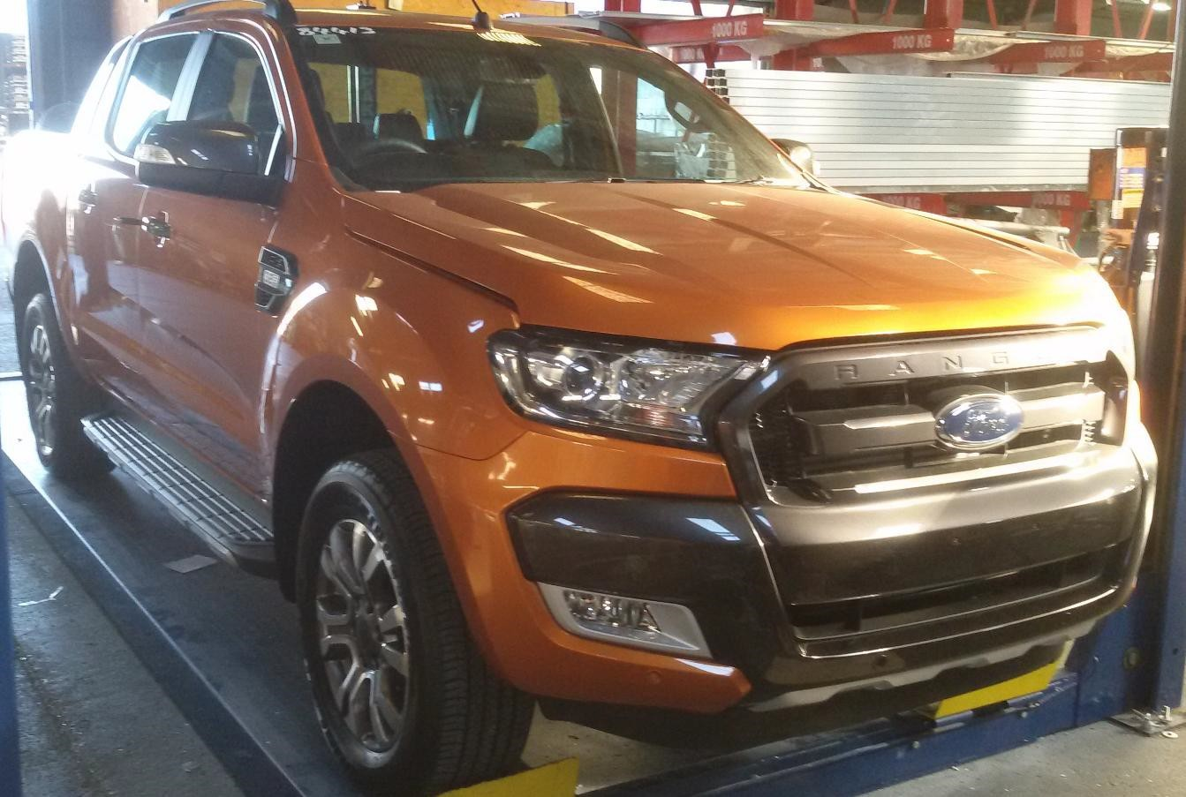
remove below kits：

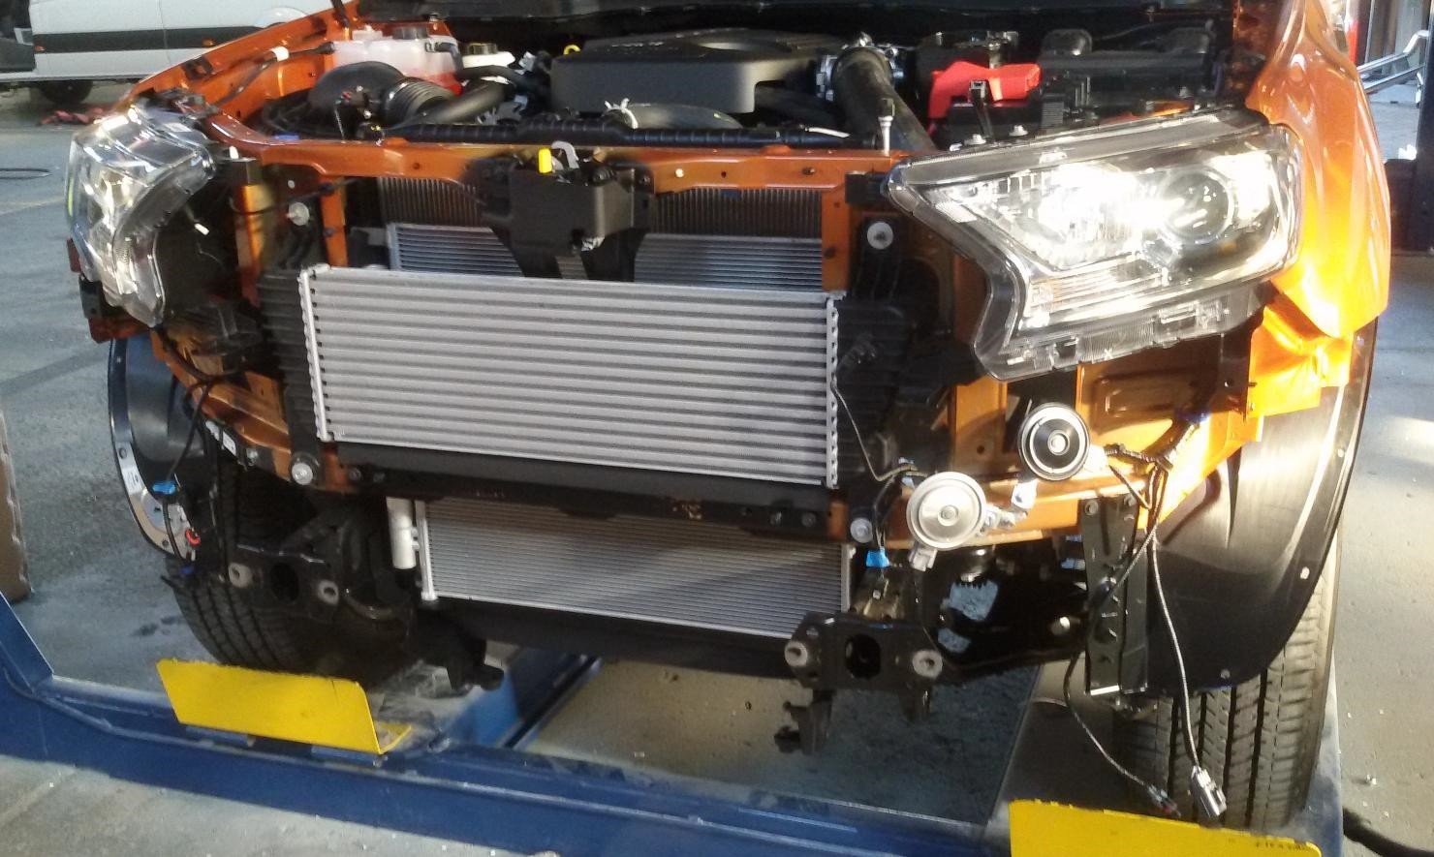

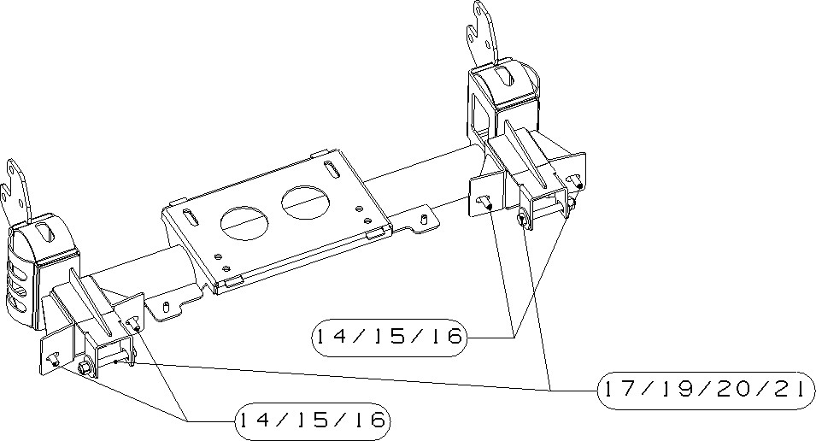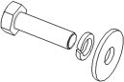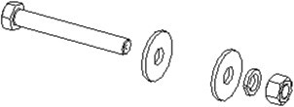
2
.
I
nstall winch frame—item 2

need use below bolt kits:
1
、
item 14/15/16
：

hexagonal head bolt
M10_30+M10 spring washer
+
M10 washer

2
、
item 17/19/20/21
：

hexagonal head bolt
M12_90_35
+
spring washer D
12
（
2

个）
+
M12 washer +M12 hexagon nut

3. install item winch frame
If need to install the winch frame, please follow the installation instruction

4.install item：Automatic auxiliary braking system

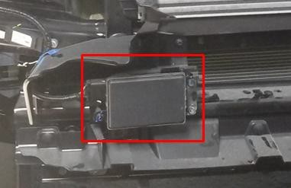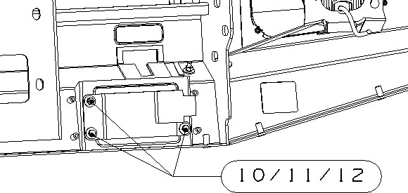

The automatic auxiliary braking system carry on the car Mounted on the bull bar

Removed the automatic auxiliary braking system from the car, then install it onto the bull bar. need use below bolt kits:：
1、 item 10/11/12： hexagonal head bolt M6_25+ M6 spring washer +M6 washer

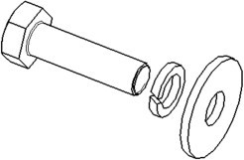

5. install item 1 bull bar

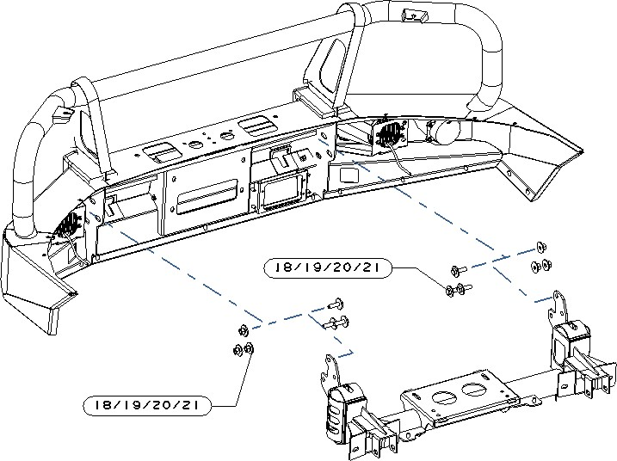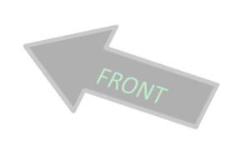

Need use below bolt kits 1、item 18/19/20/21： hexagonal head bolt M12_40+M12 spring washer（2）+M12 washer（2 个）+M12nut

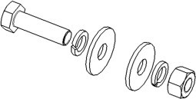

6. install item：wing
- CUT FACTORY BUMPER TO FILL UNDER LIGHTS AS SHOWN BELOW

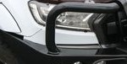

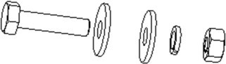

Install step：

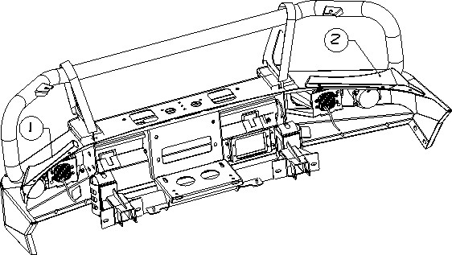

Need use below bolt kits:
1、hexagon boltM6_25 +M6 washer（2 pieces）+ M6spring washer + M6 Hexagon nut（6 pieces）

7. install item：Skid Plate（LH）/Middle Skid Plate / Skid Plate（RH）
It’s need to check to confirm that the light line and other electrical lines have been connected well before the installation of the skid plate.

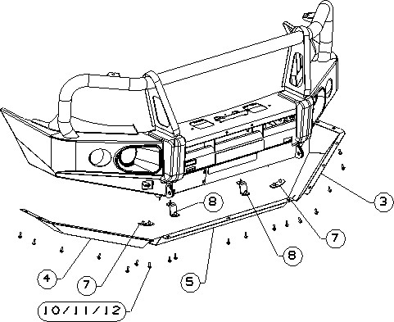

Need use below bolt kits:
1、item10/11/12： hexagonal head bolt M6_25+ M6 spring washer+M6washer

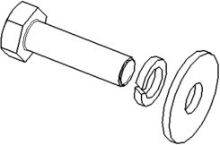

Skid plate (LH) / (RH) is connected to the middle Skid plate by junction plate 1 (7) The middle Skid plate is connected to the winch frame by junction plate 2（8）

- Carefully go over all the mounting points and ensure they have been tightened.
- Cut and fit factory inner guard lining to the wing bash plates and fix in place.

For more information check out www.rockarmor.com.au and watch our YouTube installation video.

